Blockchain-Enabled Information Sharing Within a Supply Chain: A Systematic Literature Review

In supply chain management multiple users such as Suppliers, Consumers may access system and its databases and all supply chain application may allow application owner what data to be shared with customers and what data has to be hided and all this data may store at centralized server or third part cloud servers and some malicious users may tamper or alter that data as this data stored at single centralized server and there will be no other storage to detect this data alterations and to overcome from this problem author is giving brief literature survey on Blockchain technology to migrate supply chain application from centralized server (single server storage) to decentralized Blockchain server (where data will be stored at multiple nodes or server).

In Blockchain technology same transaction data stored at multiple server with hash code verification and if data alter at one server then it will detected from other server as for same data hash code will get different. For example in Blockchain technology data will be stored at multiple servers and if malicious users alter data at one server then its hash code will get changed in one server and other servers left unchanged and this changed hash code will be detected at verification time and future malicious user changes can be prevented.

In Blockchain each data will be stored by verifying old hash codes and if old hash codes remain unchanged then data will be consider as original and unchanged and then new transaction data will be appended to Blockchain as new block. For each new data storage all blocks hash code will be verified.

In propose paper author has given lots of literature on Blockchain technology about its advantages and disadvantages. The main advantage of Blockchain is its ability of providing secure data storage and its biggest disadvantage is verifying all hash code to add new data or transaction and this verification of data all time may consume lots of memory and take more execution time.

In propose paper author is explaining about supply chain management using Blockchain technology and we implemented same concept and this concept consists of two users called SUPPLIERS and CONSUMERS.

Suppliers: This user will add new product details and this details will be stored in Blockchain as smart contract. Storing data in Blockchain will be called as Smart Contract. For each product details a new block will be created and added to Blockchain and for each block old hash code get verified and then new hash code will be generated for new block also.

Consumer: This user will fetch all product details from Blockchain and then booked a product and this booking details will be stored at Blockchain. For each Blockchain storage we can see its old and new hash code and by checking each hash code you may find that last transaction current hash code will be same with new transaction old hash code.

SCREEN SHOTS

To run project install python 3.7, MYSQL database to store new users details and Blockchain will be used to store product details and order details.

Install MYSQL and then copy content from ‘DB.txt’ file and paste in MYSQL console to create database and then start DJANGO server and open browser and enter URL as ‘http://127.0.0.1:8000/index.html’ and press enter key to get below screen

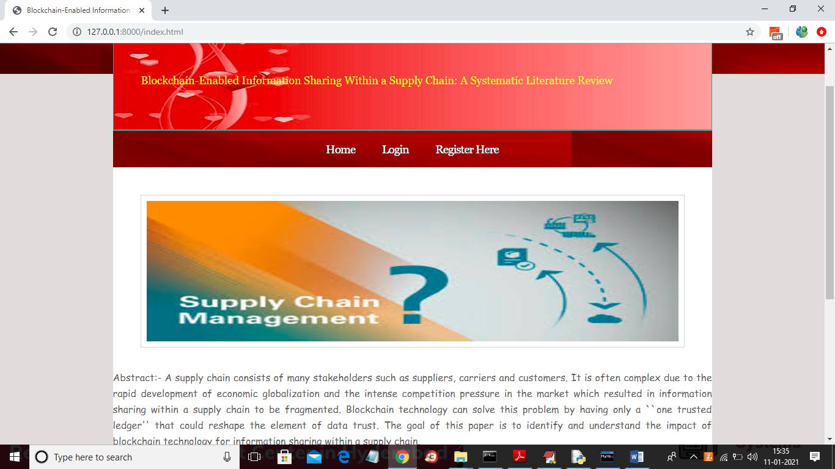

In above screen click on ‘Register Here’ link to get below screen

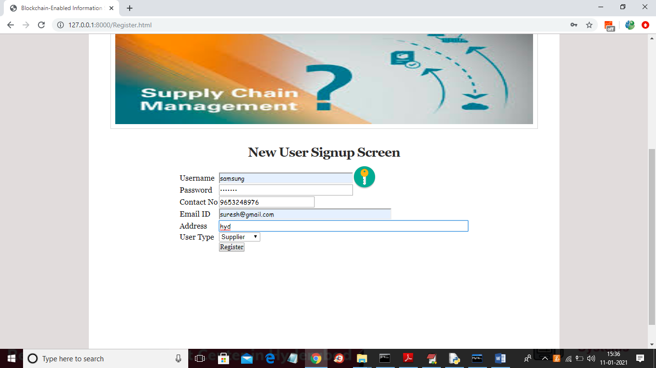

In above screen I am adding details of supplier and after clicking on ‘Register’ button will get below screen

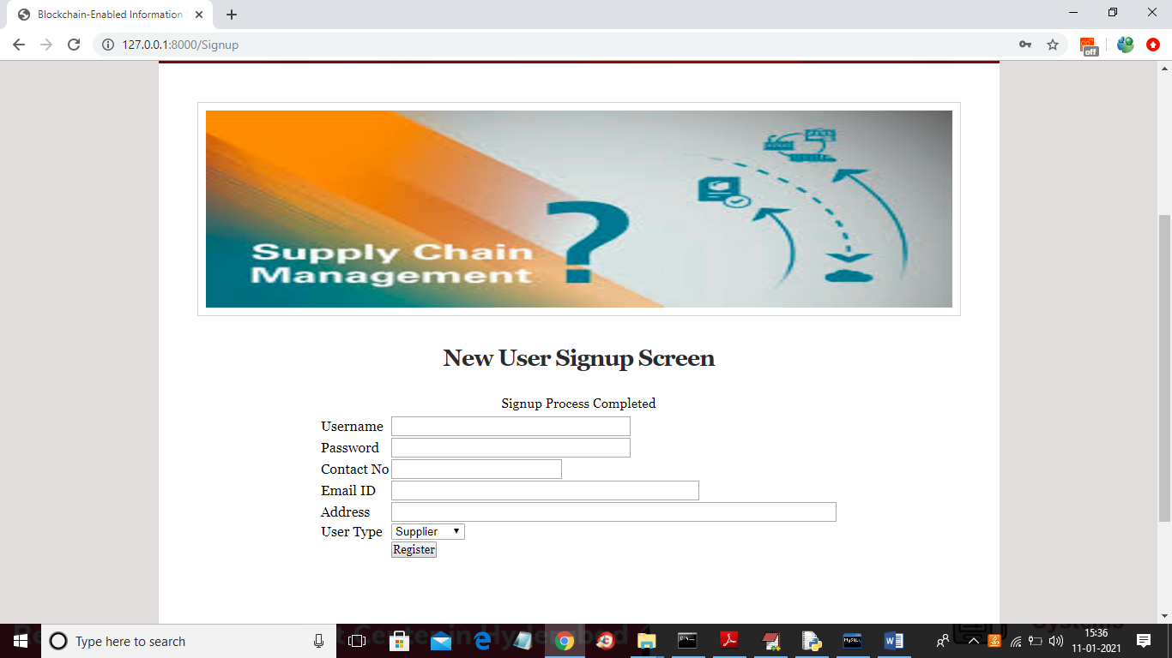

In above screen Signup process completed and now add one Consumer

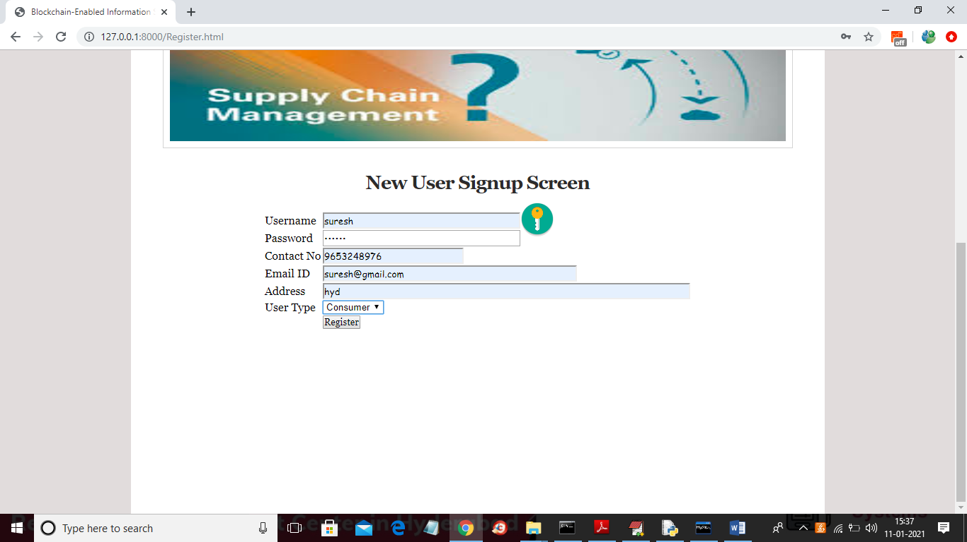

In above screen registering one consumer and now click on Login link and then login as supplier

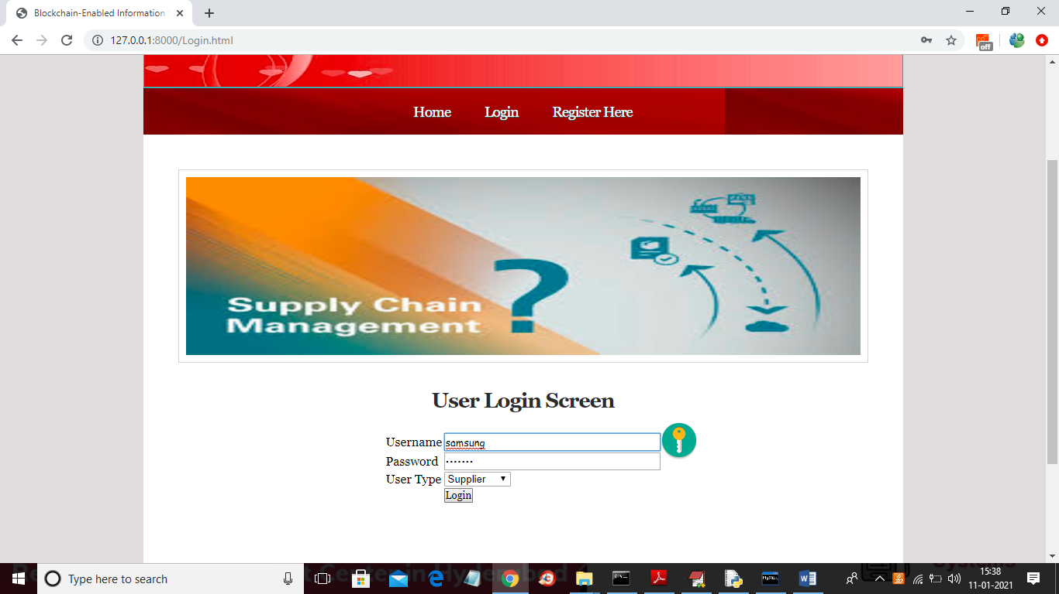

In above screen supplier is getting logged in and then after login will get below screen

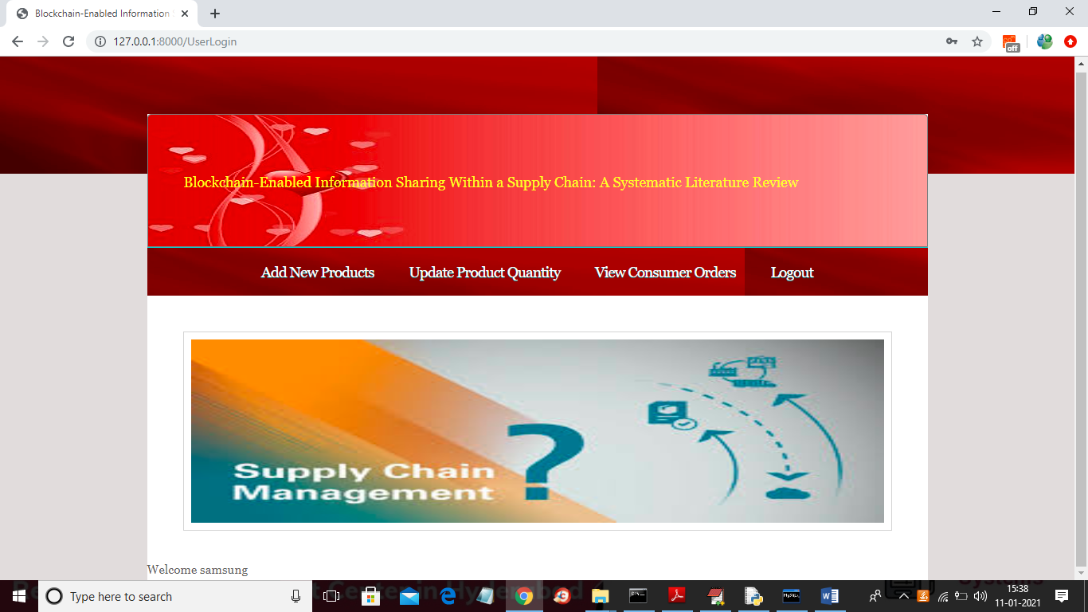

In above screen click on ‘Add New Products’ link to add new transaction to Blockchain

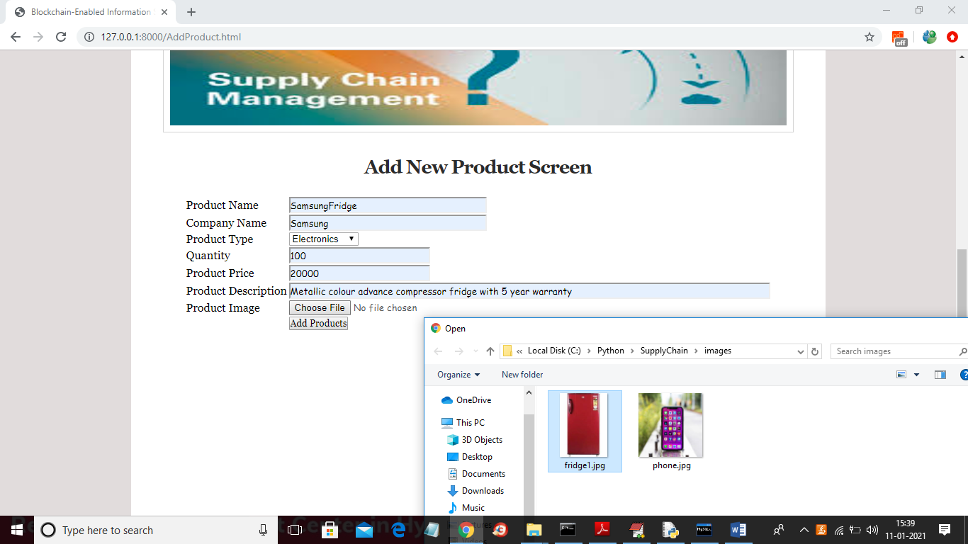

In above screen entering new product details and then uploading that product image and then click on ‘Add Products’ button to add details to Blockchain

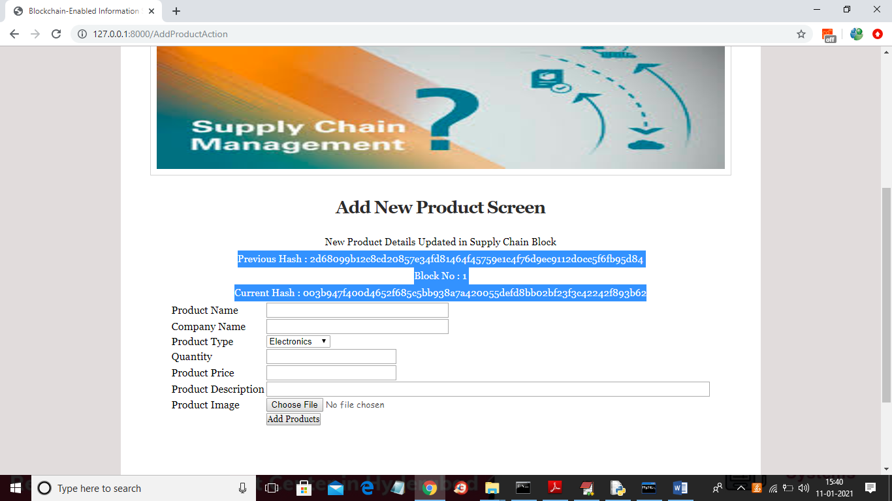

In above screen in selected blue colour text we can see to add product details Blockchain has generated old hash code and its block number and its current hash code. Now add another product then we can see the current hash code will match with old hash code of new product

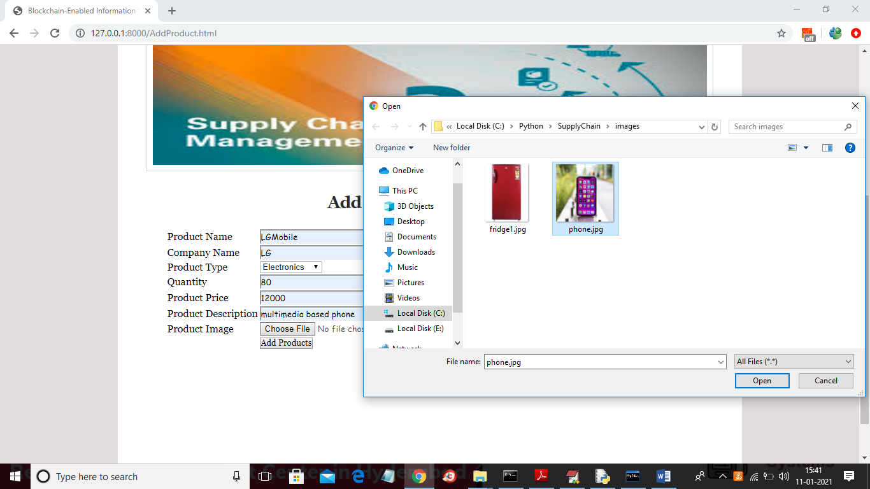

In above screen new product details are adding and after clicking on Add Product button will get below screen

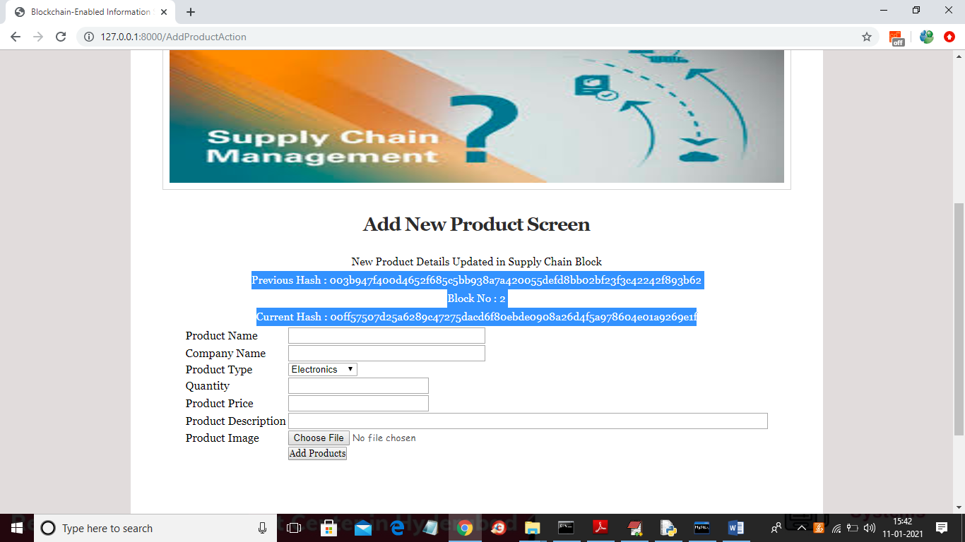

In above screen for new product also new block is created with block number as 2 and in above screens we can see previous hash of above screen is matching with current hash of before above screen. So by verifying above previous and current hash code Blockchain perform secure data storage and now Supplier can click on ‘Update Product Quantity’ link to update available product quantities

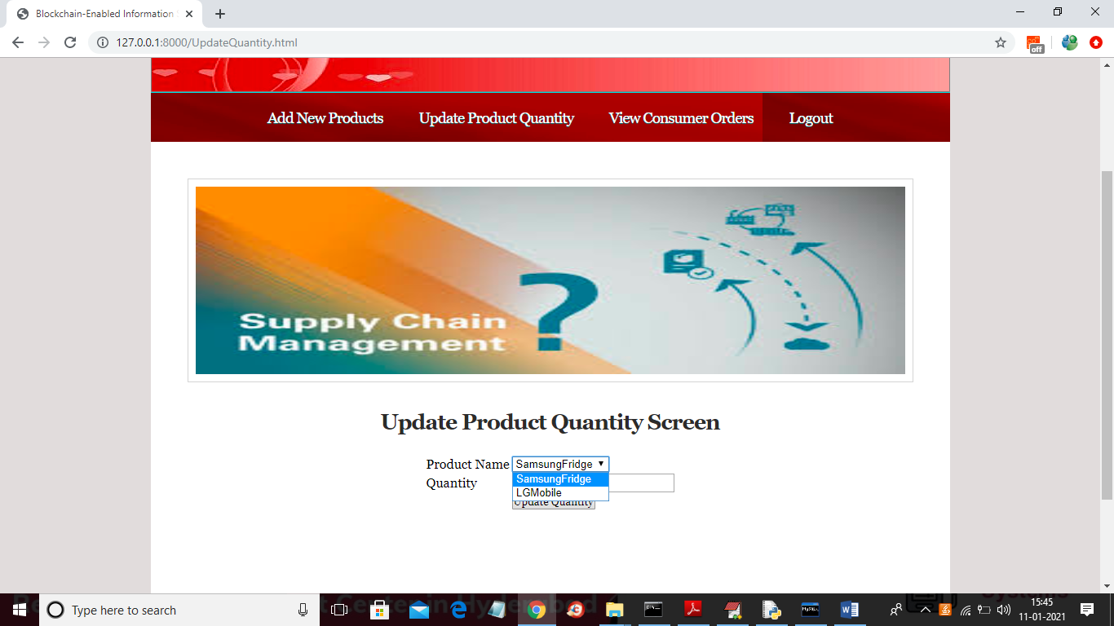

In above screen supplier may select desire product and then enter quantity to update product quantity in Blockchain

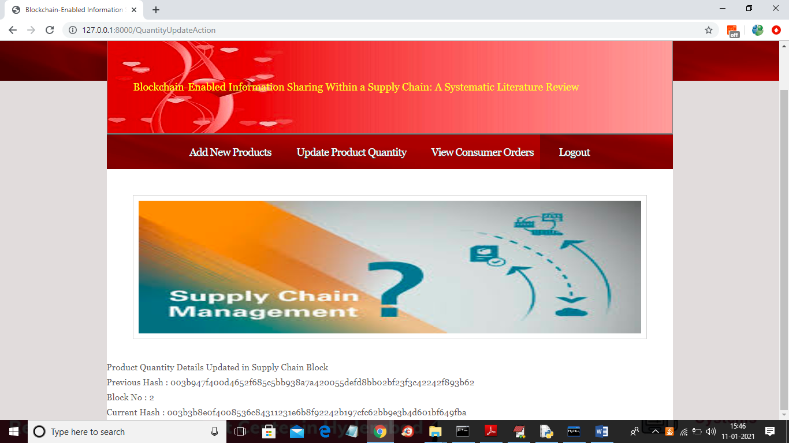

In above screen after updating quantity will get Blockchain previous and current hash code and now logout and login as consumer to book product

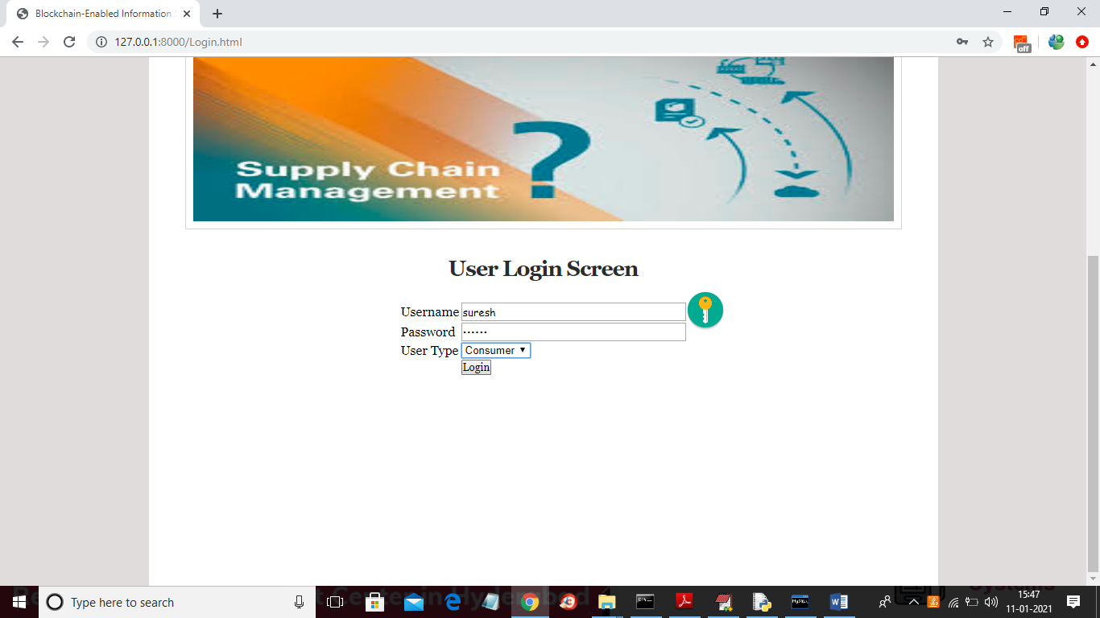

In above screen consumer is logged in and after login may get below consumer screen

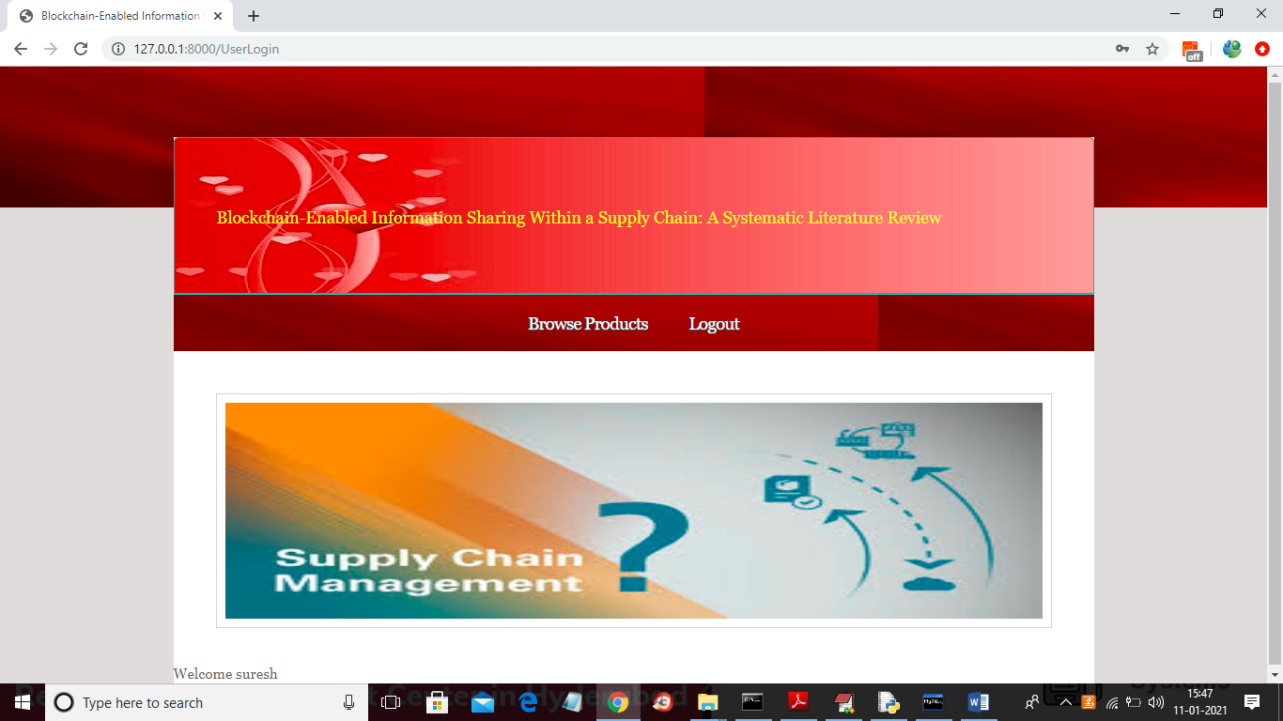

In above screen consumer can click on ‘Browse Products’ link to get below screen

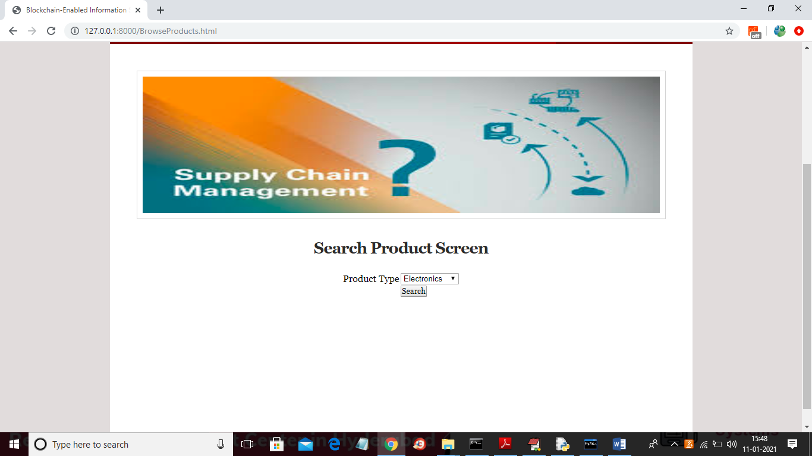

In above screen consumer can select desire product type and then click on ‘Search’ button to get all products of that type in below screen

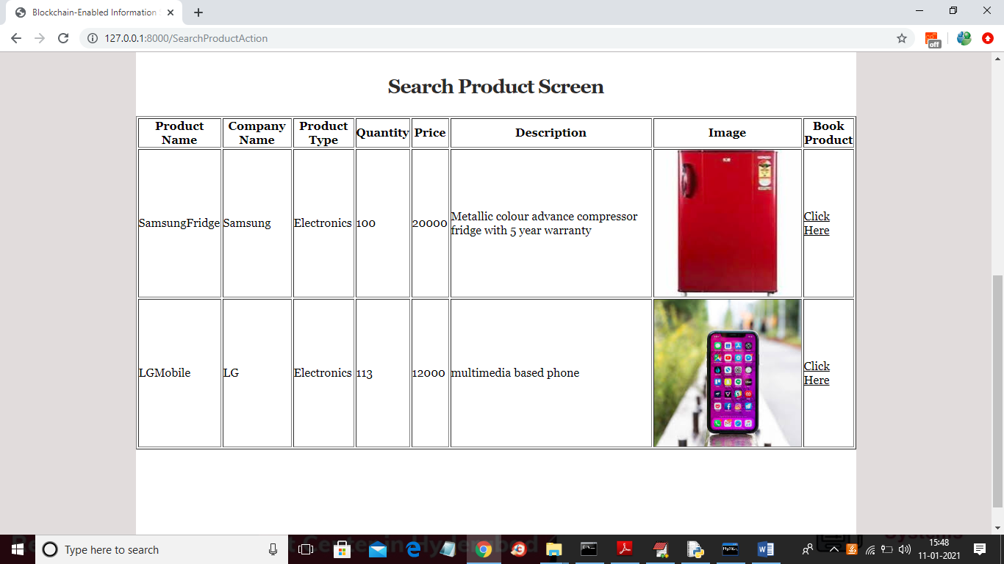

In above screen application fetching all product details from Blockchain and displaying to consumer and then consumer can click on ‘Click Here’ link to booked that product and to get below screen

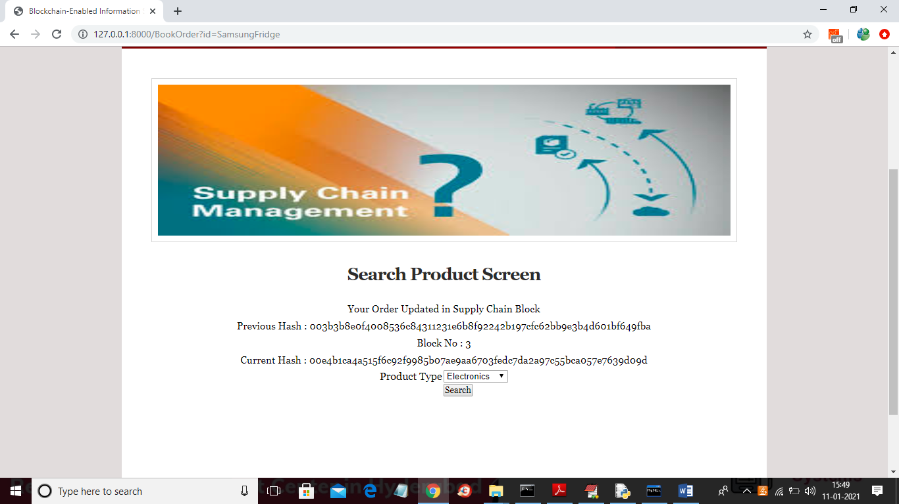

In above screen consumer booking data all stored in block chain with block number as 3 with previous and current hash code and now logout and login as supplier to view consumer booking orders

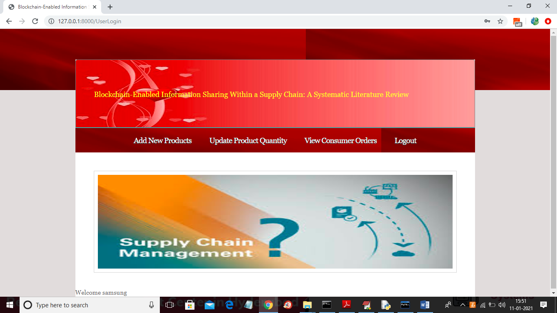

In above screen supplier can click on ‘View consumer Orders’ link to get customer order

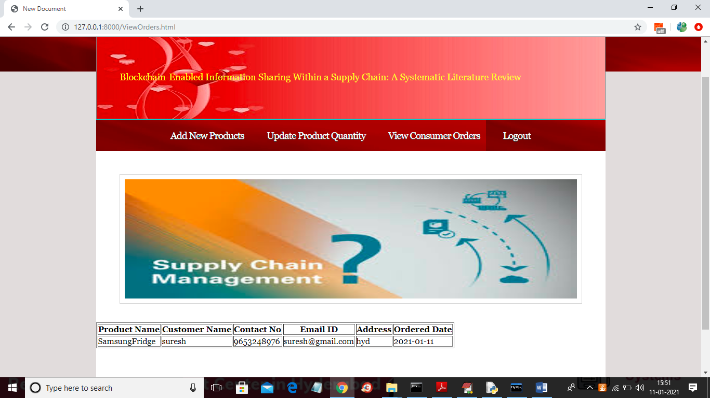

In above screen we can see booking ordered from consumer ‘suresh’. Similarly all suppliers and consumers may use this application and store their business data on Blockchain decentralized server